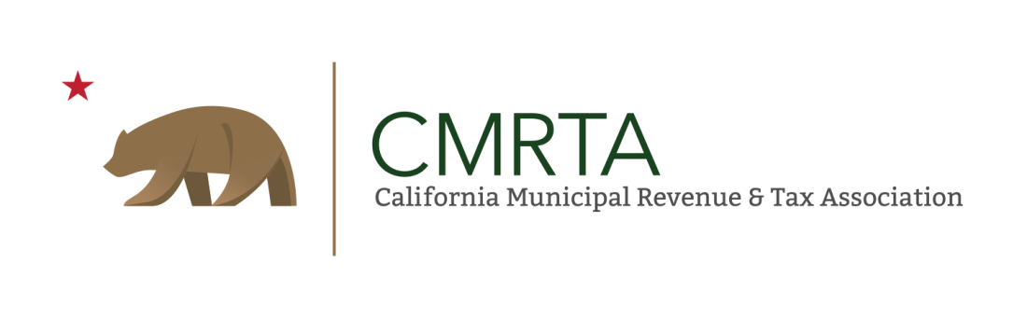

2021 CMRTA Bruno Marchetti Award

Bruno Marchetti represented the City of Stockton in the CMBTA (now CMRTA)
for many years. He served as a mentor to many revenue professionals before
there was an official program. Many of the state leaders attribute their early
success to Bruno's assistance and that made them want to do the same. To
honor Bruno's legacy, the State Board began a recognition program for those
members who consistently demonstrate the highest ideals of the municipal
revenue professional and a willingness to help their fellow revenue professionals
whenever requested. This is the highest award given by the organization.

To qualify, the potential recipient must be a Certified Revenue Officer (CRO)
who has made a permanent improvement to the organization, state-wide. Additionally, he or she must have served two (2) years on a division board and
four (4) years on the State Board. The years do not have to be consecutive.

Nominations must be submitted in writing by Friday, October 8, 2021, to Cris Gaiennie, State 1st Vice President, cgaiennie@carson.ca.us.

2021 CMRTA Bruno Marchetti Award
Application

Nominee: __________________________________________________________
Name of City / Agency: _______________________________________________________
Qualifications:
- Certified Revenue Officer
Expiration date ________________________________________________________
- Division Board Officer – 2 years required
Position and date served ________________________________________________
Position and date served ________________________________________________
- State Board Officer – 4 years required
Position and date served _________________________________________________
Position and date served _________________________________________________
Position and date served _________________________________________________
Position and date served _________________________________________________
Reasons for Nomination: (If needed, attach additional pages)
_________________________________________________________________________
_________________________________________________________________________
_________________________________________________________________________
Submitted by: _______________________________________________________________________
Submit electronically to:
CMRTA 1st Vice President, Cris Gaiennie
cgaiennie@carson.ca.us

DEADLINE: Friday, October 8, 2021, by 5:00 p.m.

